Based on paper https://www.researchgate.net/publication/316021797_Comparison_of_the_Device_Lifetime_in_Wireless_Networks_for_the_Internet_of_Things
and questions asked to Claude.ai

- 4 states for a sensor
Table II p. 4
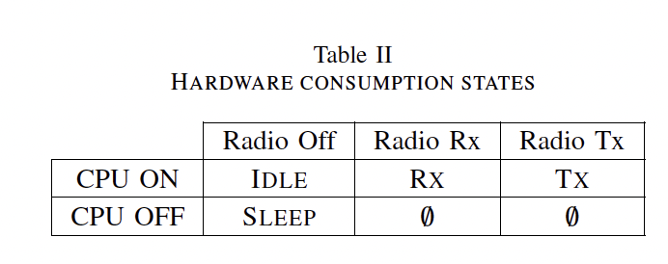
- Power P corresponding to each state for each technology:
"chosen hardware parameters" p.9
Table V and VI p. 9-10
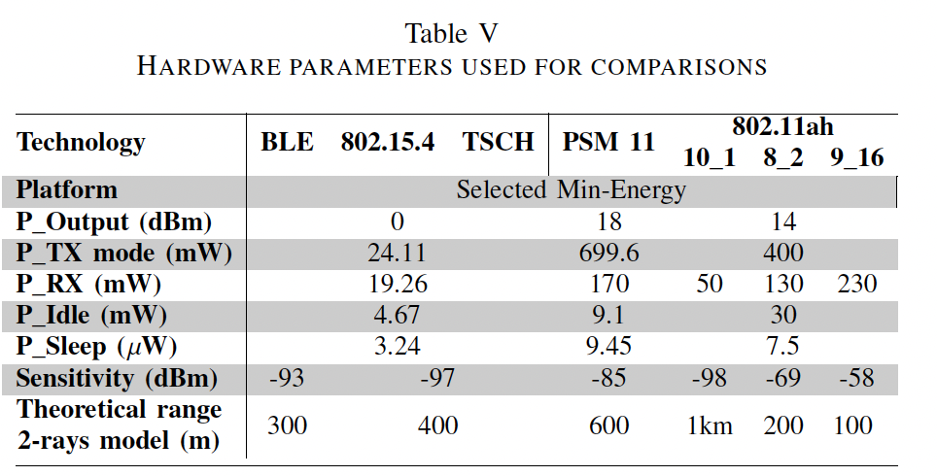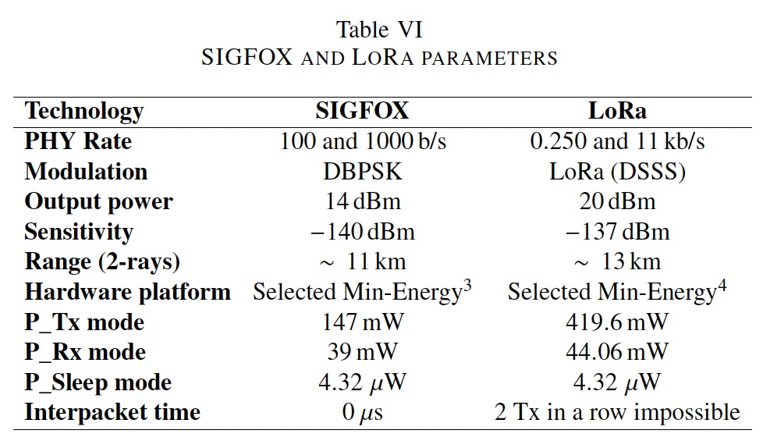
- Basic energy formula E(J) = P(W) x t(s)
E consumed by = ∑ over the 4 states of P x time spent in state

- TX is when the sensor transmits
ideally time spent in TX​ = speed of transmission x qty of bits to send

- qty of bits to send for one user data packet, on top of size of user data packet itself, depends on protocol.

  - Figures 2 to 11 should allow approximations for some or all of the protocols.
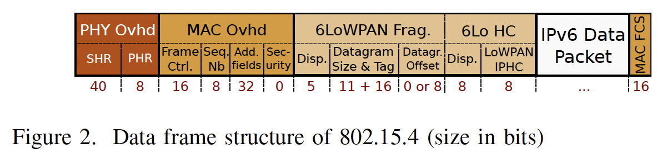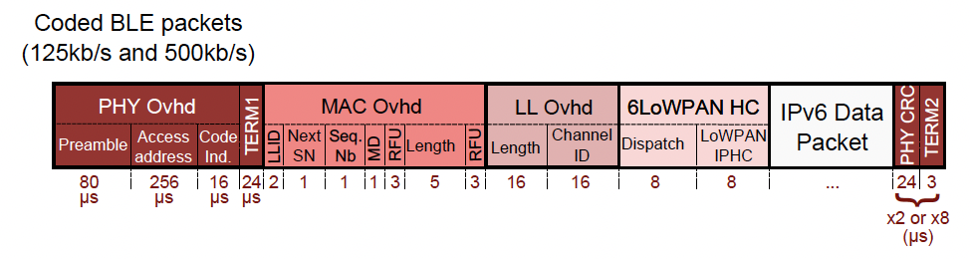

- Each technology has a max packet size, incl.protocol data. Nfr is the number of packets necessary to send a user data packet of a given size, that can be calculated based on the above and this max packet size (III. B s_{a})
time spent in TX​ = speed of transmission x qty of bits to send per packet (protocol included) x Nfr

- Ntr is the average number of transmissions required for one succesful transmission — if 20% of transmissions get lost, then I need to send 125 transactions for 100 to arrive, and Ntr=1.25 (equation 5).
Ntr depends on loss rate for which an hypothesis can be taken.
time spent in TX​ = speed of transmission x qty of bits to send per packet (protocol included) x Nfr x Ntr

- For each transmission we can add the idle time (P_Idle x fixed time) and for each succesful transmission, we can add the energy for reception (P_RX x fixed time)

- For synchronous technologies, given that we know the periodicity of transmissions, we can add the energy of a synchronization transmission when there are no transmissions for longer than the max time allowed tsyn (fig 12)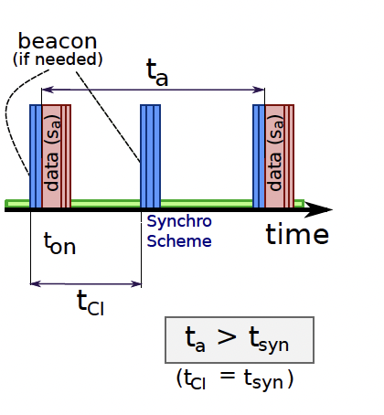

- Then we can then add the energy time in sleep ≈ remaining time x P_Sleep
This until now approximates the energy needed for a full set of tranmissions over one segment on a given period of time for a time, with distance and infrastructure neglected

- Lower consumption of energy if smaller distance:
  - We could consider an approximation like
P_TX_real = P_TX x (distance_real / distance_max)
  - Possibly with a factor/exponent that reflects the environment
- Higher consumption of energy if higher distance
  - We could roughly consider that if distance_real > distance_max, then there will be multiple segments for the same transmission, Nsegments = distance_real / distance_max, with all the energy for one segment multiplied by Nsegments
--> this is in energy and can then be multiplied by the local carbon intensity factor of electricity to get CO2-eq

- Infrastructure
  - We could consider that for each technology, there are associated equipments, that each have an average lifespan and a number of messages per year, that in the base case would be (more or less informed) hypotheses, and that if someone is modeling a full system they may adjust.
  - Then we would take the full LCA footprint (incl fabrication but also usage in average conditions — that actually may include hypotheses on # of messages) and amortize it:
CO2-eq per message ≈ CO2-eq from LCA / (lifespan x average number of messages per year)
  - When distance_real > distance_max, then this cost of infrastructure could be multiplied by Nsegments, reflecting the multiplication of infrastructure
  - Sample table generated quickly through AI
